**to open the django project:(in windows)**

1. **download all source file to your machine.**

<https://github.com/DooominicGuo/deep_learning_web>

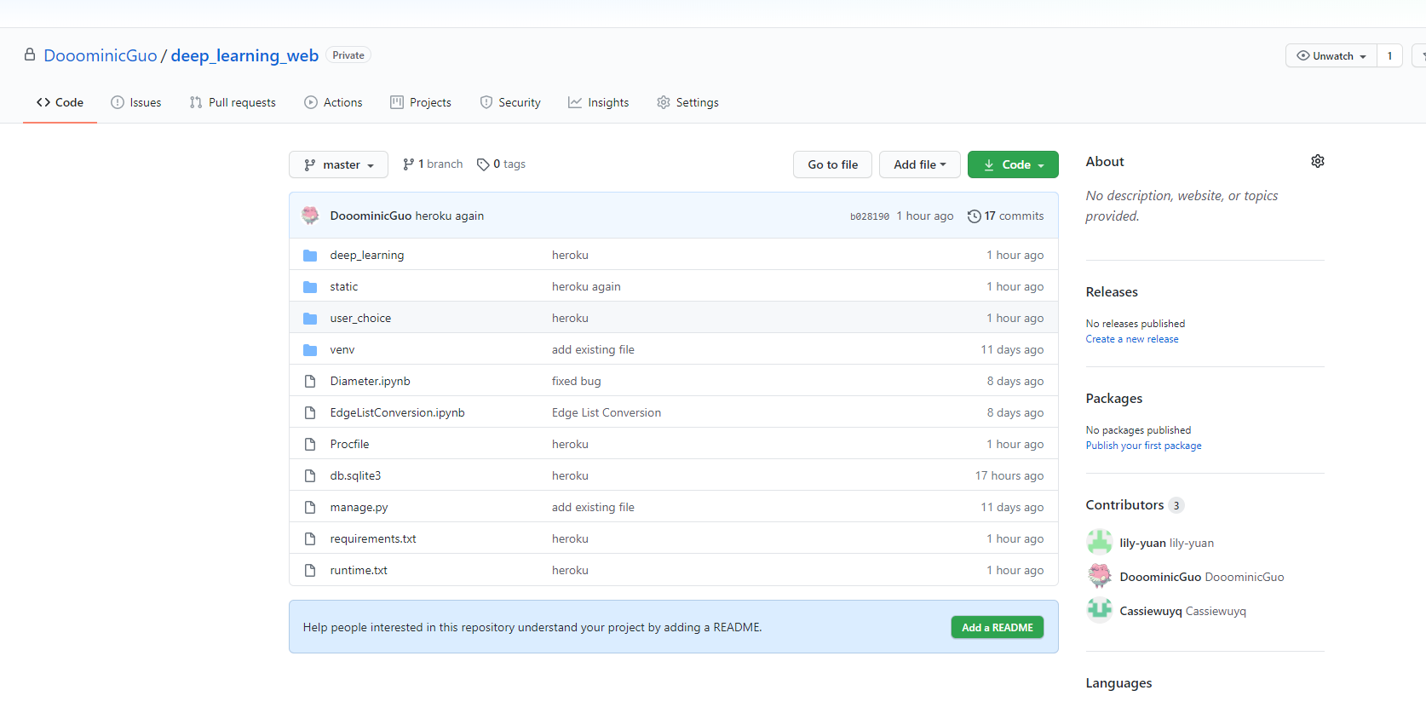

1. **open command and install python.**

<https://www.python.org/downloads/>

if correctly installed, you should be able to open the command and type

py –-version



1. **install django on your local machine. (already installed when you download the python file)**

you can easily install django by typing: py -m pip install django

1. **run the server**

as the venv folder is a virtual environment for python and it has already been set up. You can easily use it without downloading django.

frist find the file in venv/ Script/ actiavate.bat.

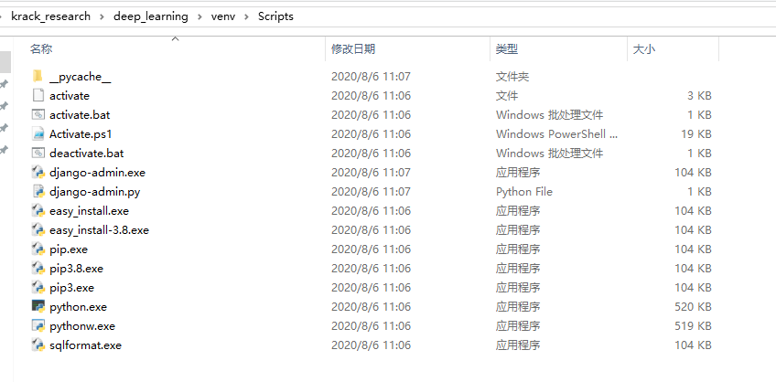

then in the command type the whole directory of this file.

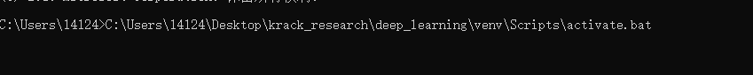

in this case this is the whole directory of activate.bat in my system.

if everything goes well, you should enter the virtual environment:

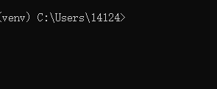

then change your direction to the folder with manage.py in it.

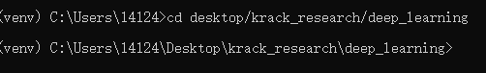

to run django server on your local machine, type py manage.py runserver

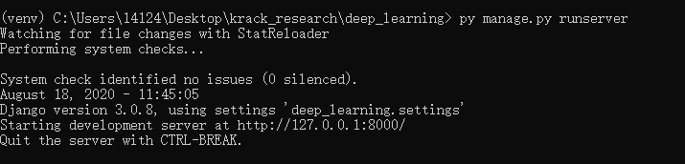

1. **open the webpage**

go to your browser and type in the link showing on your command. (127.0.0.1:8000)

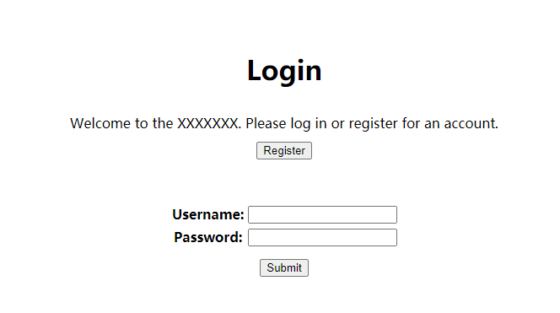

Cong! Now we are in the webpage!

**FUNCTIONS OF THE user_selection webpage:**

feel free to explore yourself. It now supports login, register, and as a registered account you can do your choice and record them.

we have a default user with user_name:1234 and password: 1234

**TO　OPEN　THE DATABASE （SQLITE）:**

1. download sqlite <https://sqlitebrowser.org/>
2. find the database file in your folder.

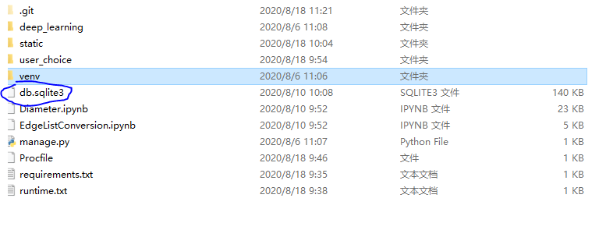

1. then select browse the data.

there are two tables that are useful: user_choice_choice, and user_choice_profile

user_choice_choice is used to record how users chose the data.

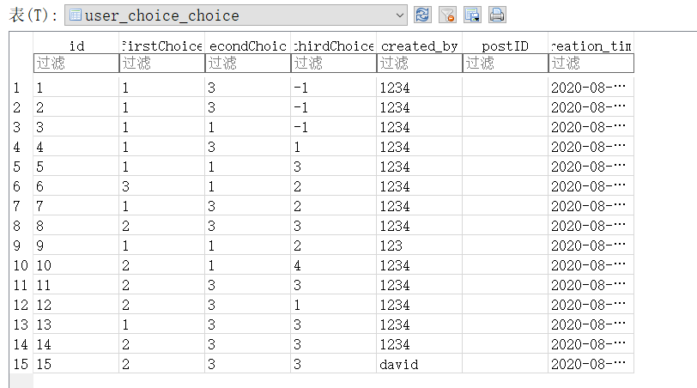

user_choice_profile is used to record users’ profile.

